# Windows basic commands

1. If u want to open windows folder from command prompt, then type “explorer.exe .”

Dot at the end means open a command prompt from current working directory

# Basic linux commands

### Go to root directory

Cd /

### Go to specific directory

cd <directory name>

### Home directory

‘~’

### Create a file

touch abcd

now abcd file is create

1. Create a folder

mkdir java

A folder called java will be created

1. Remove a file

rm fileName

1. Create a file with contents

echo “hello-world” >hello2.txt

1. To open windows folder of current directory

When u type this command from current directory a windows folder will be opened

Type “explorer.exe .”

1. To go one folder back 🡪cd ..
2. To navigate to a path

cat <path>

1. Create & edit the file in cmd prompt

“Vi file.txt”

Vi means visual improved –it’s a text editor-

When u type vi- it will create a file and open that file for us in command prompt itself

To edit and save that file

------------

1. First we have to edit that file🡪 type “I” for entering into insert mode,

after typing “I”(stands for insert) only u can write the text

1. Then type everything and then click “Escape” in keyboard button and type caps “ZZ” then the file will be saved automatically

Getting Out of vi

**Press escape button in your keyboard and type capital “ZZ”** The easiest way to **save your changes and exit vi** is with the ZZ command. When you are in the command mode, type **ZZ**. The **ZZ** command works the same way as the **:wq** command.

The command to quit out of vi is **:q**.

“:q!” This lets you exit vi without saving any of the changes.

The command to save the contents of the editor is **:w**

1. To view file contents

cat <filen1> <file name 2> <file name 3>

1. Hostname of ur Ubuntu machine

hostname -I

1. List out all folders in current directory

Ls

1. Echo <any data> once u execute same data will be printed to the console

echo hi santhoshi

“hi santhoshi”

1. Create a variable Export b= Tata consultancy services
2. Echo that variable Echo b
3. Terminate the running process

Ctrl+c or Ctrl+D

1. Creating a file
2. Create a folder called “java” – mkdir java
3. Moving to that folder –cd java //now the cursor will go into that folder
4. To go 1 folder back 🡪 cd ..
5. To see the path where you are type “pwd”—present working directory

## wsl

1. To open a linux folder type the command –“ \\wsl$” like in windows we have “start .”

If u type the above command in windows , it will open a folder where linux is installed

Generally ur workspace is located in \\wsl.localhost\Ubuntu\home

|  |  |
| --- | --- |
| To open a folder of ur current directory in windows | In Ubuntu |
| Start . | explorer.exe .  This says open explorer.exe from current directory (dot means current directory) |

### “pwd” List out the current working directory

Pwd means present working directory

It will tell u the present working directory

1. Chown-Change owner

COPY --chown=node:node ./package.json ./

Copy --chown=user:group

Here left side node is user,right side node is group

1. Create a directory

WORKDIR /home/node/app

Means a directory will be created if doesn’t exist and it will set the ownership to root.

RUN mkdir -p /home/node/app

Mkdir will also create a directory

* 1. RUN mkdir -p /home/node/app
  2. WORKDIR /home/node/app

We are then creating a directory of **/home/node/app** prior to the **WORKDIR** instruction. This will prevent a permissions issue since **WORKDIR** by default will create a directory if it does not exist and set ownership to **root**.

1. Create a directory

RUN mkdir -p /home/node/app

To create a directory that doesn’t exist we need to use –p command because it expects immediate parent to exist

# Connect from windows to Ubuntu server

1. To get latest package manager-- Type command “sudo apt update” , “sudo apt upgrade”
2. Install ssh server on the Ubuntu machine –“ sudo apt install openssh-server”
3. to start ssh server “sudo service ssh start”,”
4. To see whether ssh service is running or not “sudo service ssh status “
5. To see whether ssh service is running or not- “sudo systemctl status ssh” –
6. Optional -To enable ssh “sudo systemctl enable ssh”,to start “sudo systemctl start ssh”
7. update the firewall to open the port 22-“sudo ufw allow ssh”
8. to know ip address of ur Ubuntu server “hostname -I” or”ip a”

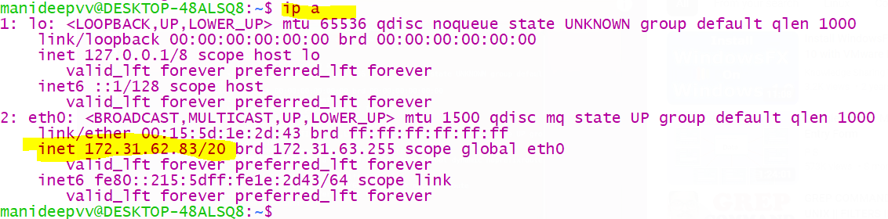

1. so far, we have successfully installed ssh server on Ubuntu machine,

to connect to Ubuntu machine,

* + 1. first in that ubuntu machine ssh server must be installed and
    2. then we should know the ipaddress of that machine and
    3. name of that machine- here machine name is “manideepvv” and password (I used my docker pass- MANIdeep123) to connect to my Ubuntu machine



1. now from my windows machine I will connect to my Ubuntu machine

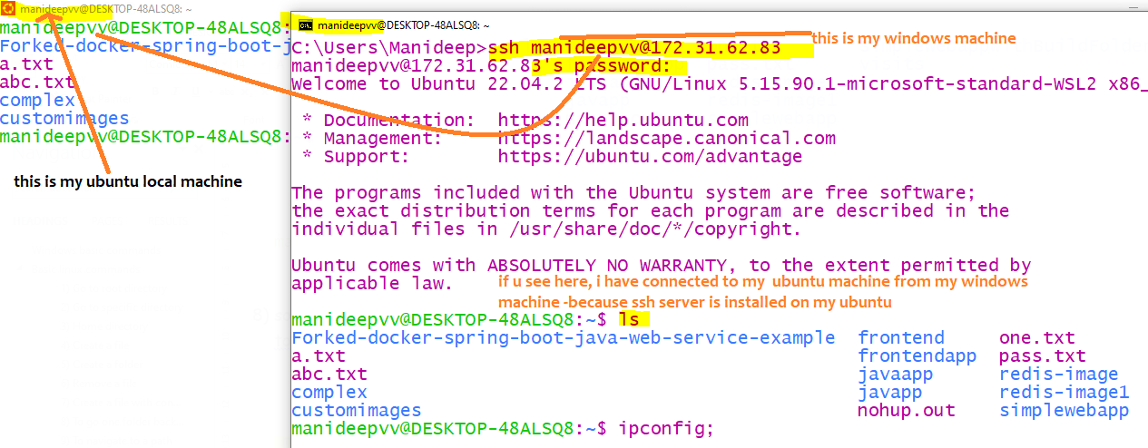

1. if u want to exit the connection from that machine, then simply type exit